**ADD SSL Certificate in windows to make it secure/verified Access**

**Step1:- Applying opensource SSL certificate to Talend Services in widows/Linux machine.**

**Step2:- Check url listening on Https Not secure access**

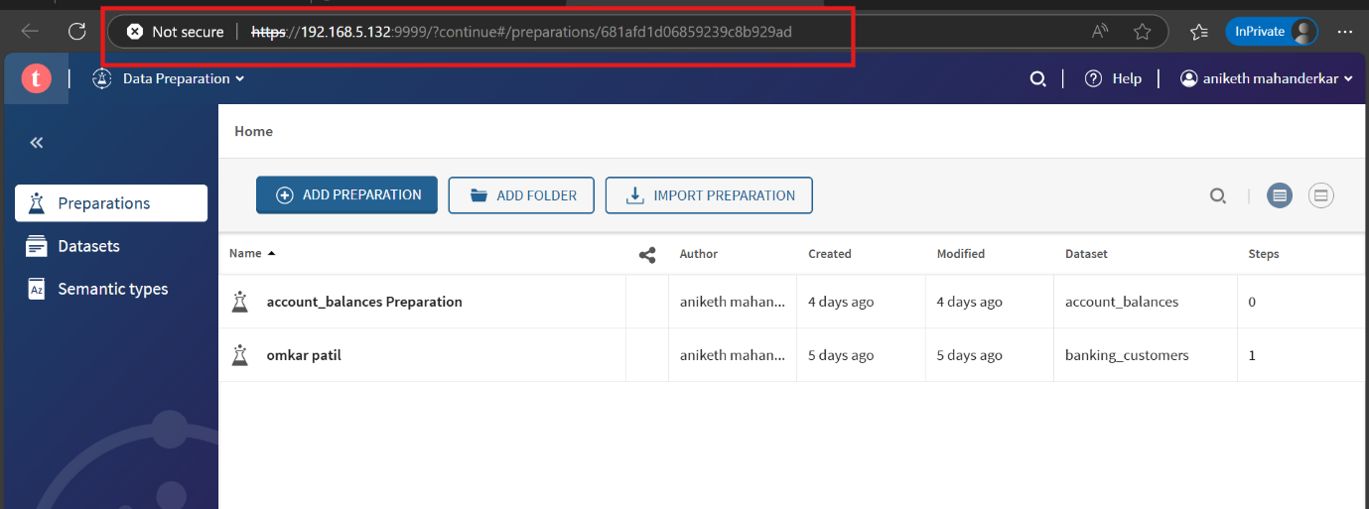

**Step3:- Download the certificate from Bowser.**

**\*open the https Browser**

**\*Click on not secure Tab.**

**\*Goto Details Section**

**\*Export the certificate.**

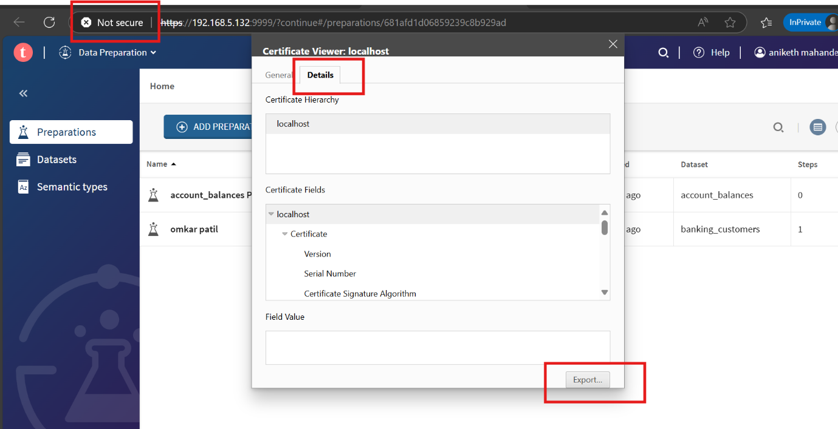**\*It will download on .cert or .cer file**

**Step4:- Add the Exported/downloaded certificate into Windows machine.**

**\*Import the certificate in Trusted root Store.**

**\*Press Win + R → type mmc**

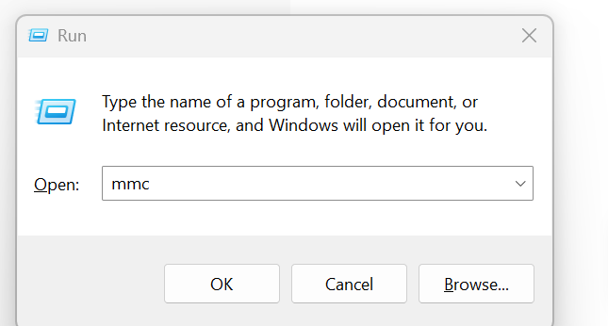

**\*Click File → Add/Remove Snap-in...**

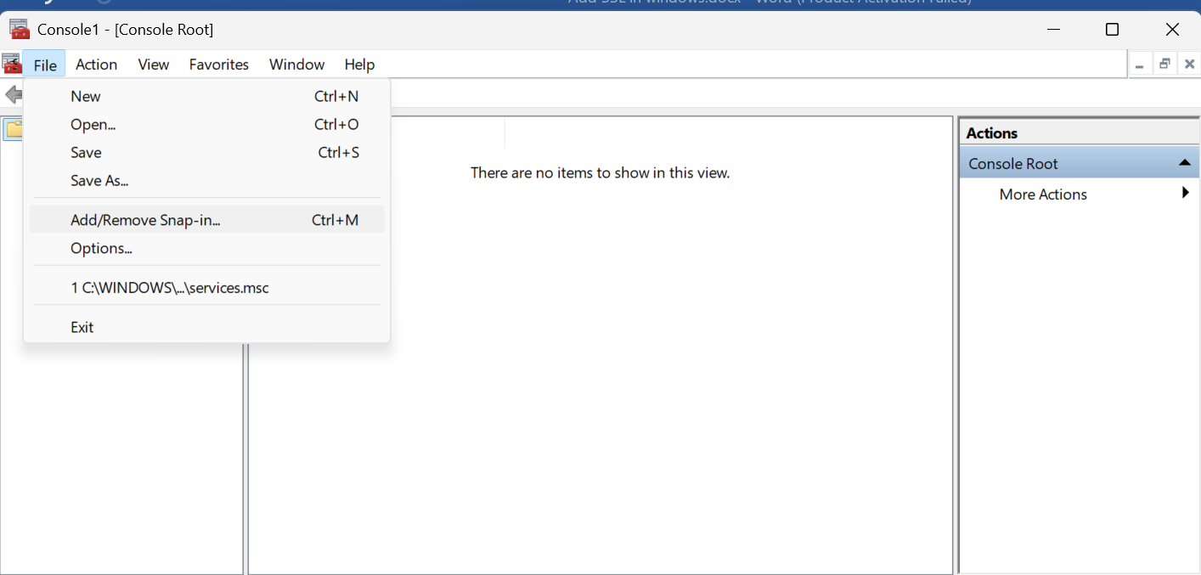

**\***In the dialog: Select **Certificates** → Click **Add >** Choose:  
✅ **Computer account**  
→ Click **Next**, then **Finish**.

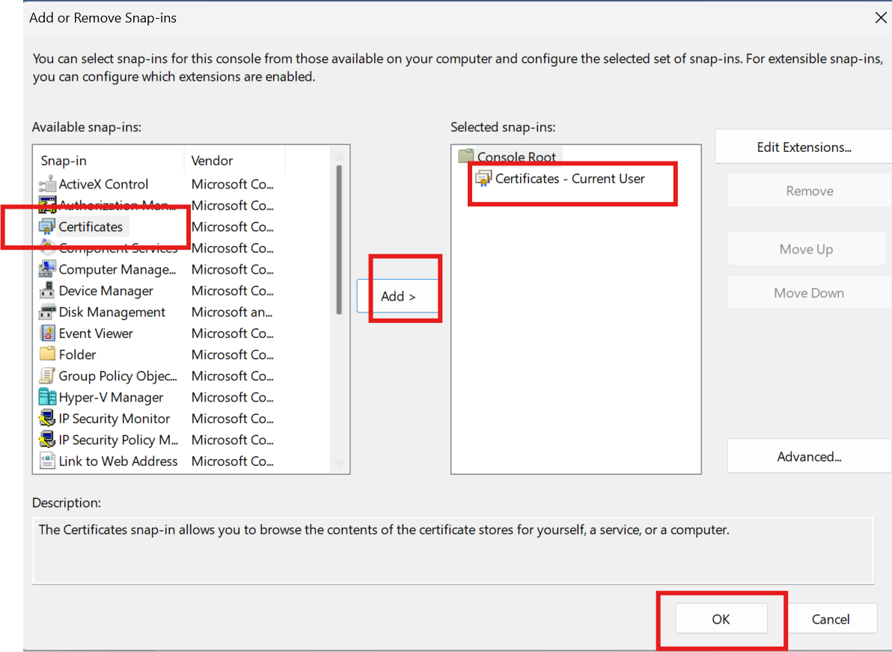

*Back in the main MMC window, click OK.

* Now expand:

* 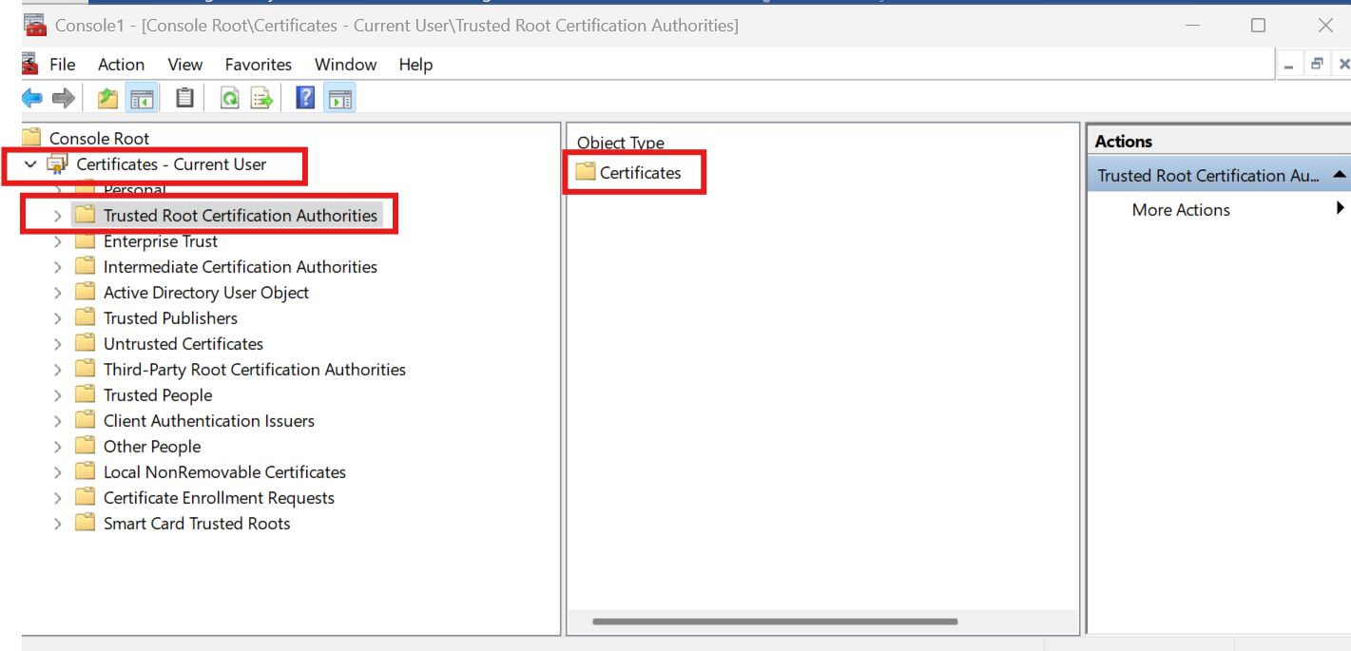Certificates (Local Computer)  
  → Trusted Root Certification Authorities  
  → Click on Certificates.

*Right-click on Certificates folder under Trusted Root Certification Authorities:

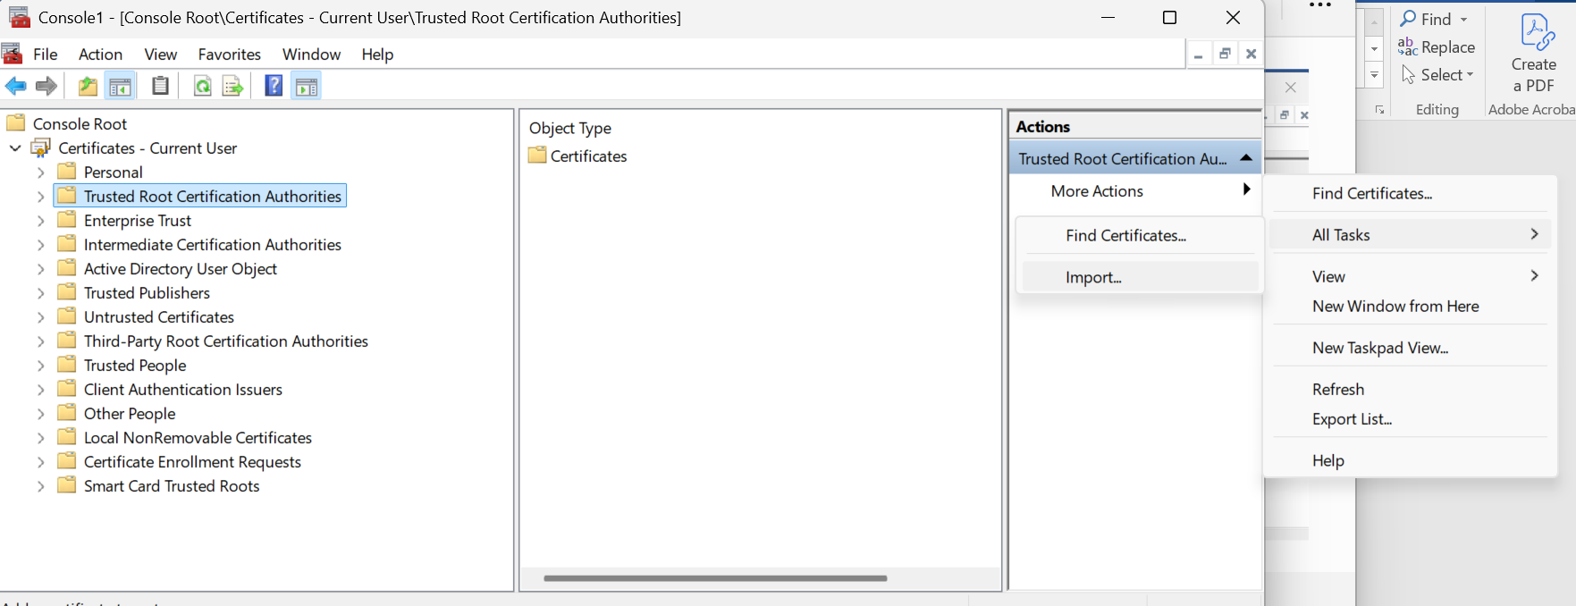Choose All Tasks → Import...

*In the Certificate Import Wizard:

Click Next.

Browse to the .cer file you saved earlier (my-cert.cer) → Click Next.

* + Choose:  
    ✅ Place all certificates in the following store  
    and ensure it says Trusted Root Certification Authorities.
  + 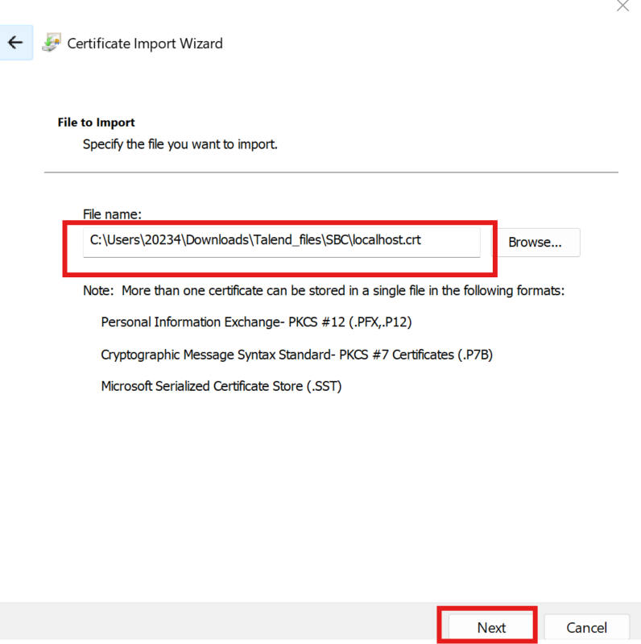Click Next → Finish.

A success message should appear: "The import was successful."

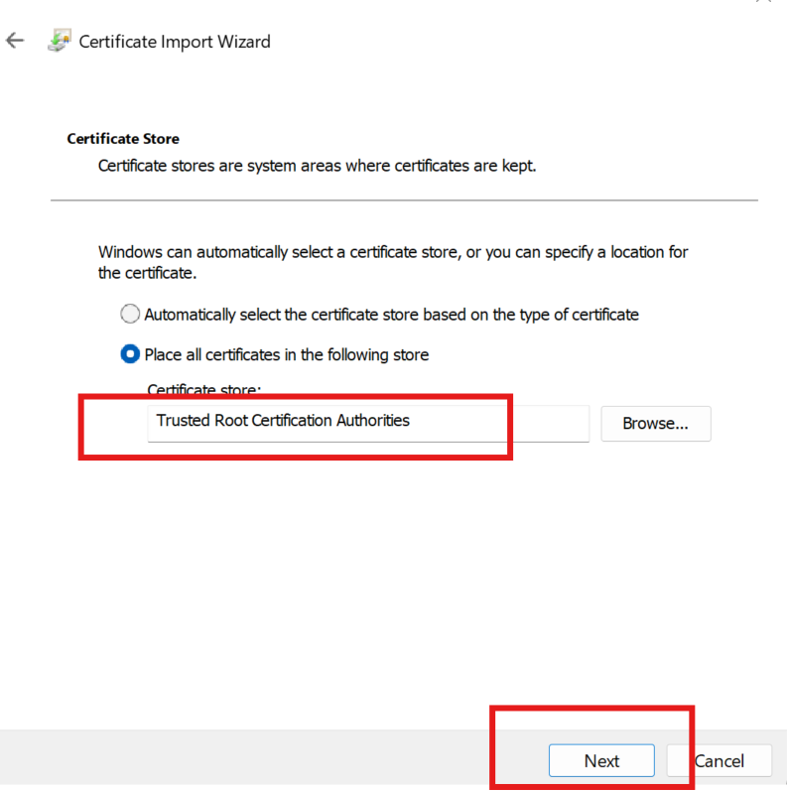

## *Restart Microsoft Edge

* Close all Edge windows.
* Open Edge again.
* Visit your site (https://your-site.local or whatever domain you're using).

